**BILL OF MATERIALS**

|  |  |  |
| --- | --- | --- |
| Slno. | Name of Material | Price |
| 1 | Arduino Mega  2560 R3 | 589/- |
| 2 | Ph Sensor | 2350/- |
| 3 | Motor | 150/- |
| 4 | Buzzer | 18/- |

**Arduino Mega 2560 R3**

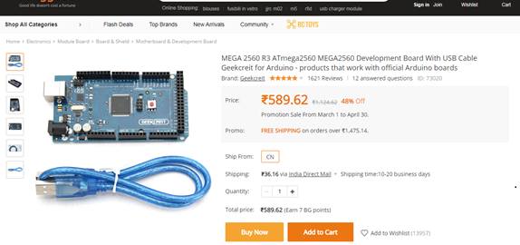

**Ph sensor**

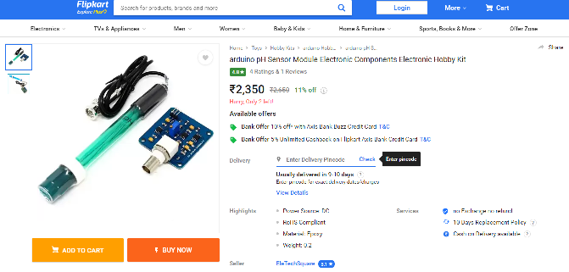

**Buzzer**

